The Most Sacred Heart of Jesus.
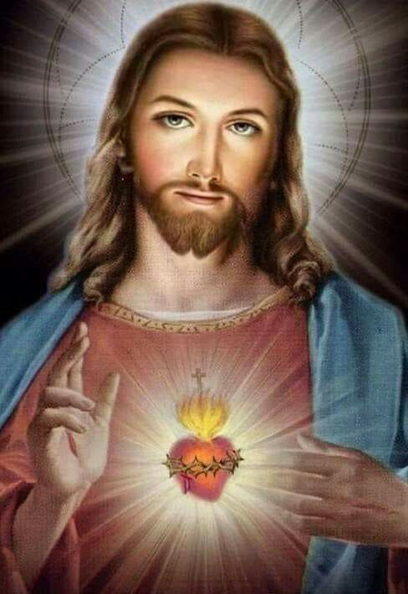

First Reading:
Moses said to the people: ‘You are a people consecrated to the Lord your God; it is you that the Lord our God has chosen to be his very own people out of all the peoples of the earth.
‘If the Lord set his heart on you and chose you, it was not because you outnumbered other peoples: you were the least of all peoples. It was for love of you and to keep the oath he swore to your fathers that the Lord brought you out with his mighty hand and redeemed you from the house of slavery, from the power of Pharaoh king of Egypt. Know then that the Lord your God is God indeed, the faithful God who is true to his covenant and his graciousness for a thousand generations towards those who love him and keep his commandments, but who punishes in their own persons those that hate him. He is not slow to destroy the man who hates him; he makes him work out his punishment in person. You are therefore to keep and observe the commandments and statutes and ordinances that I lay down for you today.’

Responsorial Psalm:
The response: The Lord’s kindness is everlasting to those who fear him
My soul, give thanks to the Lord,
all my being, bless his holy name.
My soul, give thanks to the Lord
and never forget all his blessings. Resp:
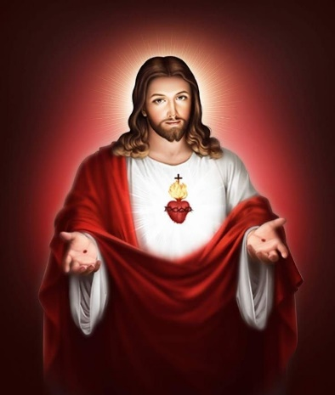
It is he who forgives all your guilt,
who heals every one of your ills,
who redeems your life from the grave,
who crowns you with love and compassion. Resp:
The Lord does deeds of justice,
gives judgments for all who are oppressed.
He made known his ways to Moses
and his deeds to Israel’s sons. Resp:
The Lord is compassion and love,
slow to anger and rich in mercy.
He does not treat us according to our sins
nor repay us according to our faults. Resp:

Second Reading:
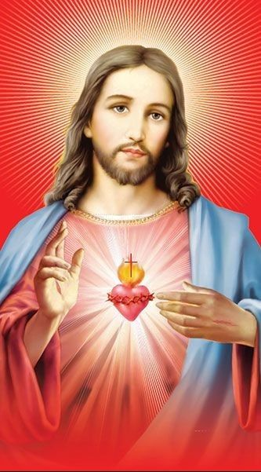
My dear people,
let us love one another
since love comes from God
and everyone who loves is begotten by God and knows God.
Anyone who fails to love
can never have known God, because God is love.
God’s love for us was revealed
when God sent into the world his only Son
so that we could have life through him;
this is the love I mean:
not our love for God, but God’s love for us
when he sent his Son to be the sacrifice that takes our sins away.
My dear people,
since God has loved us so much,
we too should love one another.
No one has ever seen God;
but as long as we love one another
God will live in us and his love will be complete in us.
We can know that we are living in him
and he is living in us because he lets us share his Spirit.
We ourselves saw and we testify
that the Father sent his Son as saviour of the world.
If anyone acknowledges that Jesus is the Son of God,
God lives in him, and he in God.
We ourselves have known
and put our faith in God’s love towards ourselves.
God is love and anyone who lives in love lives in God,
and God lives in him.

Gospel:
Jesus exclaimed, ‘I bless you, Father, Lord of heaven and of earth, for hiding these things from the learned and the clever and revealing them to mere children. Yes, Father, for that is what it pleased you to do. Everything has been entrusted to me by my father, and no one knows the Son except the Father, just as no one knows the Father except the Son and those to whom the Son chooses to reveal him.
‘Come to me, all you who labour and are overburdened, and I will give you rest. Shoulder my yoke and learn from me, for I am gentle and humble in heart, and you will find rest for your souls. Yes, my yoke is easy and my burden light.’

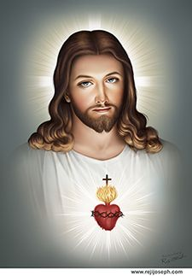
Reflections:
A picture of the Sacred Heart was a hugely popular image of Christ for generations of Catholics. It speaks of the love of Christ, a love most totally shown upon the cross. The pierced heart of Christ proclaims that “greater love” of which Jesus says: “No one can have greater love than to lay down one’s life for one’s friends.” The image of the Sacred Heart offered the message of love in a very personal way, echoes in St Paul’s words, “I live by faith in the Son of God who loved me and gave himself for me.” St John gives us one of the shortest yet most profound statements about God in all of the Bible: “God is love.” He adds that “God’s love was revealed when God sent into the world his only Son.”
Jesus is the supreme revelation of God who is love. All authentic love is life-giving and that is uniquely true of Jesus, the revelation of God’s love. In the gospel, He uses the image of “resting” to speak of that love. He invites all who are burdened to come to him and to find rest, to find life. Even a slight inkling of the tremendous love of God for us can have a transforming effect. It can empower us to love one another as God has loved us.
Today, the devotion to the Sacred Heart is centered around the centrality of Divine love, encouraging all to trust in God’s overflowing benevolence towards the world He has made.
The heart of Jesus opened by the spear is the place where all sinners find a place to hide not for shame but for shelter and to be washed clean by His Grace flowing from His wounded side.
